Calendar App Mockups
Home/Dashboard (Web)
Here's your high-fidelity web dashboard mockup for the ROCA app:
The design includes all the key elements from the spec:
- Dark navy sidebar — Navigation with Dashboard active (green highlight), plus all app sections
- Liturgical season banner — Green gradient for Ordinary Time, Week 21
- Today's Scripture — Matthew 16:13-20 with pull-quote
- Upcoming Events — 4 events with category color dots, times, locations, and amenity icons (livestream, accessible, childcare, RSVP Required badge)
- My Serving — Volunteer assignments with confirmed ✓ and pending ⏳ status chips
- Prayer Focus — Warm-tinted card with the Guatemala mission
- Alerts — Orange-bordered card with nursery volunteer gap and meeting change notice
The styling follows a modern SaaS aesthetic (similar to Notion/Linear) with clean whitespace, rounded cards, and subtle shadows — professional but warm for a church context.

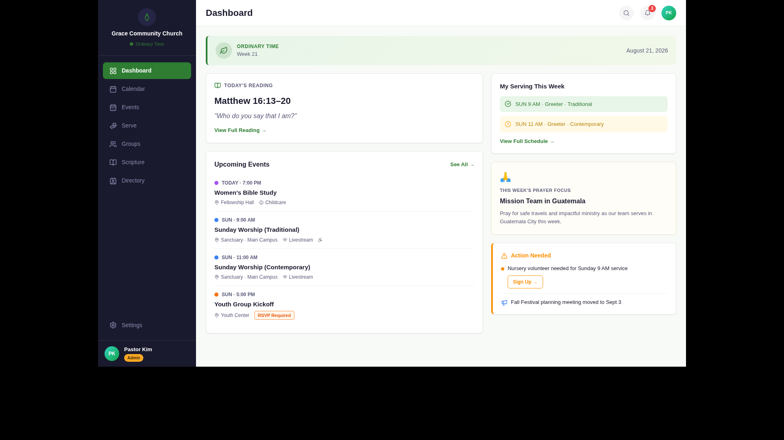
Calendar View (Web)
Here's your high-fidelity Calendar View (Monthly) mockup for the ROCA web app:
The design captures all the key elements from the spec:
- Calendar toolbar — Month/year navigation, view toggle (Month/Week/Day/List), campus and category filter dropdowns, and green "+ New Event" button
- Monthly grid — 7-column layout with color-coded event pills showing service times, studies, and meetings
- Today highlighted (Aug 21) — Green circle on date number with subtle green cell tint
- Event pills — Category-colored chips: 🔵 Worship, 🟢 Men's Study, 🟣 Women's Study, 🔴 Staff, 🟠 Admin, 🟡 Outreach
- Overflow handling — "+1 more" link for cells with more than 3 events
- Right detail panel — Shows today's events (Women's Bible Study) and upcoming days at a glance
- Bottom legend — Color-dot key for quick scanning
- Liturgical context — Ordinary Time badge integrated into the view
The aesthetic follows the same Google Calendar × Notion Calendar style with the ROCA liturgical personality — clean grid, rounded pills, and the green Ordinary Time theming throughout.
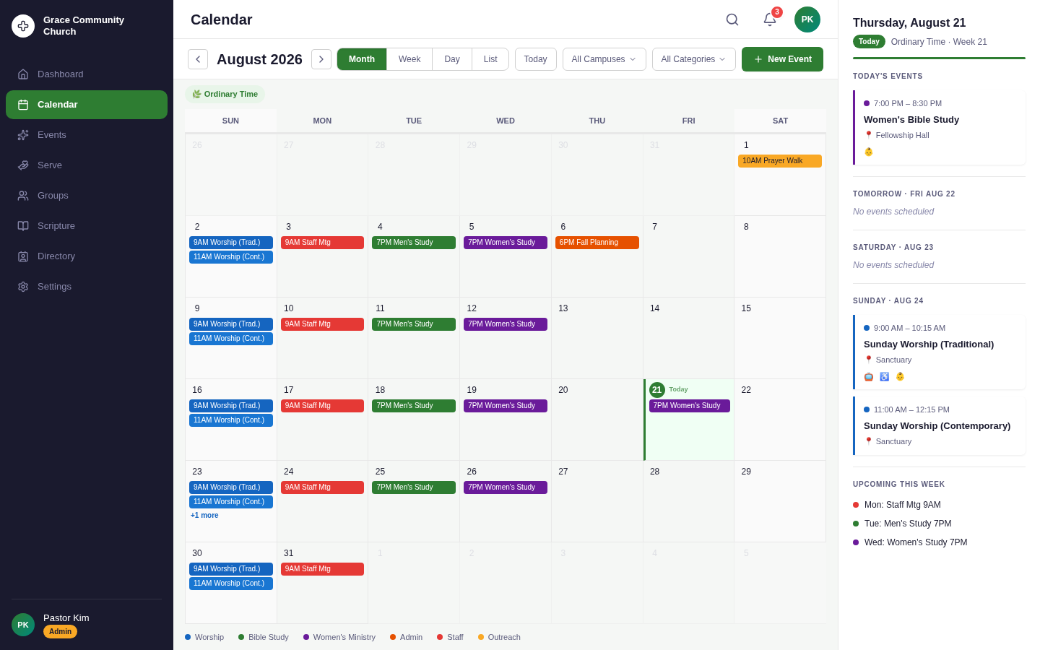

Event Detail Flyout Panel
Here's your high-fidelity Event Detail flyout panel mockup:
The design shows the event detail as a right-side slide-in panel overlaying the dimmed calendar — similar to how Google Calendar or Notion handles detail views:
- Category badge — Blue "WORSHIP" pill at the top for instant context
- Event title — "Sunday Worship (Traditional)" in bold 22px
- Metadata rows — Date, time, location, recurrence, and visibility with icons
- About section — Full event description
- Amenities grid — 2×2 chips: Livestream, Wheelchair Accessible, Childcare, Parking — each with a colored accent
- Scripture readings — This week's three readings (Isaiah, Psalm, Matthew) in a subtle card
- Volunteer roster — 3 confirmed roles (green ✓) + 1 open Nursery gap (⚠️ orange with "Sign Up →")
- Contact — Pastor Kim with email/phone icons
- Sticky action bar — "Watch Livestream" (primary green) + "Add to Calendar" (outlined) + attendance count
The flyout has a left drop-shadow for depth, with the August 2026 calendar visible but dimmed in the background — giving spatial context to where the user came from.

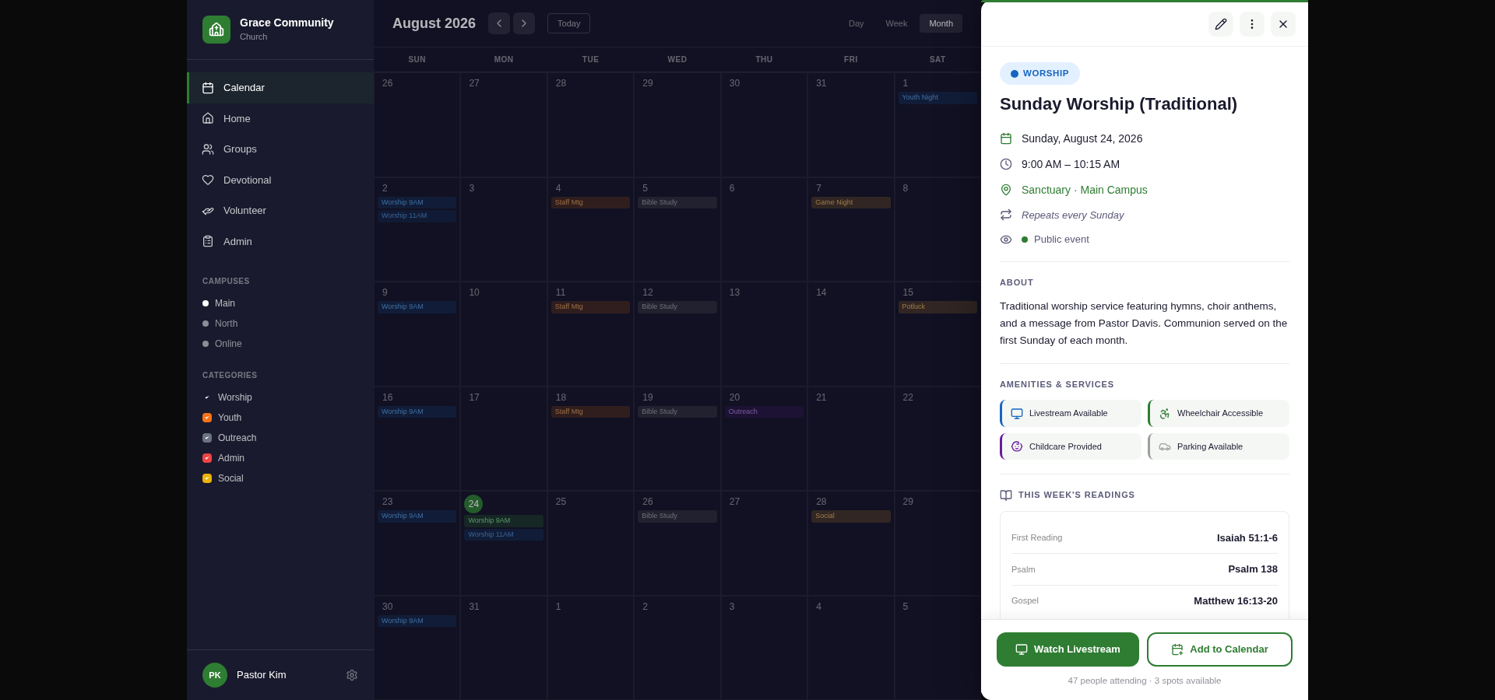

Volunteer Schedule View
Here's your high-fidelity Volunteer Schedule View mockup:
The design delivers a professional scheduling matrix that makes gaps immediately visible:
- Alert banner — Amber strip at top: "3 volunteer gaps need to be filled for the next 2 weeks" with quick-action link
- Schedule matrix — 6 roles × 7 events grid showing the full two-week roster
- Status indicators — Green ✓ (confirmed), yellow ⏳ (pending), orange ⚠️ OPEN (gap with dashed border)
- Gap highlighting — Nursery row has warm orange tint with pulsing OPEN cells and "+ Assign" cues, making unfilled positions immediately obvious
- Toolbar actions — Send Reminders, Auto-Schedule (with sparkle icon), and Export buttons
- Summary bar — "42 assignments · 39 confirmed · 3 gaps" with color legend
The aesthetic follows professional scheduling tools (like When I Work or Deputy) — clean alternating rows, sticky role column, and strong visual hierarchy where gaps demand attention while confirmed slots recede into the background.
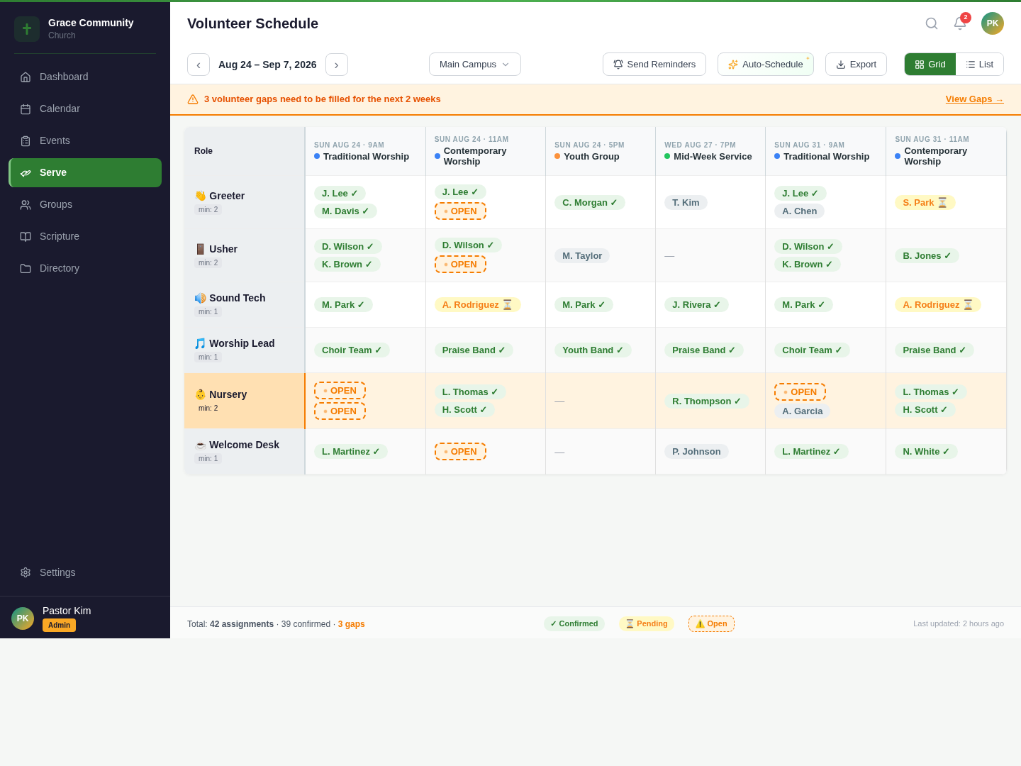

Create/Edit Event Modal
Here's your high-fidelity Create/Edit Event Modal mockup, Alain — showing all 4 steps of the wizard in a single 2×2 reference view:
The design documents the complete event creation flow:
| Step | Contents |
|------|----------|
| **Step 1: Basics** | Event title, category dropdown (with color preview), event type, description textarea, image upload zone |
| **Step 2: When & Where** | Date/time pickers, All Day/Recurring toggles, campus & room dropdowns, availability badge, conflict check success banner |
| **Step 3: Options** | RSVP/Childcare/Livestream toggle switches, max capacity input, visibility radio group, contact person search, tag chips |
| **Step 4: Review & Publish** | Full summary card with all metadata, three-action footer: Back / Save as Draft / Publish ✓ |
Design highlights:
- Progress bar fills proportionally at each step (1/4 → 4/4) with Ordinary Time green
- Progress dots (● ○ ○ ○ through ● ● ● ●) reinforce position
- Conflict detection integrated into Step 2 with green "No conflicts" confirmation
- Room availability shown inline with capacity and accessibility info
- Review card uses a light green tint (#F0FFF4) to feel like a "preview" of the published event
- Three-way publish — users can go back, save draft, or publish immediately

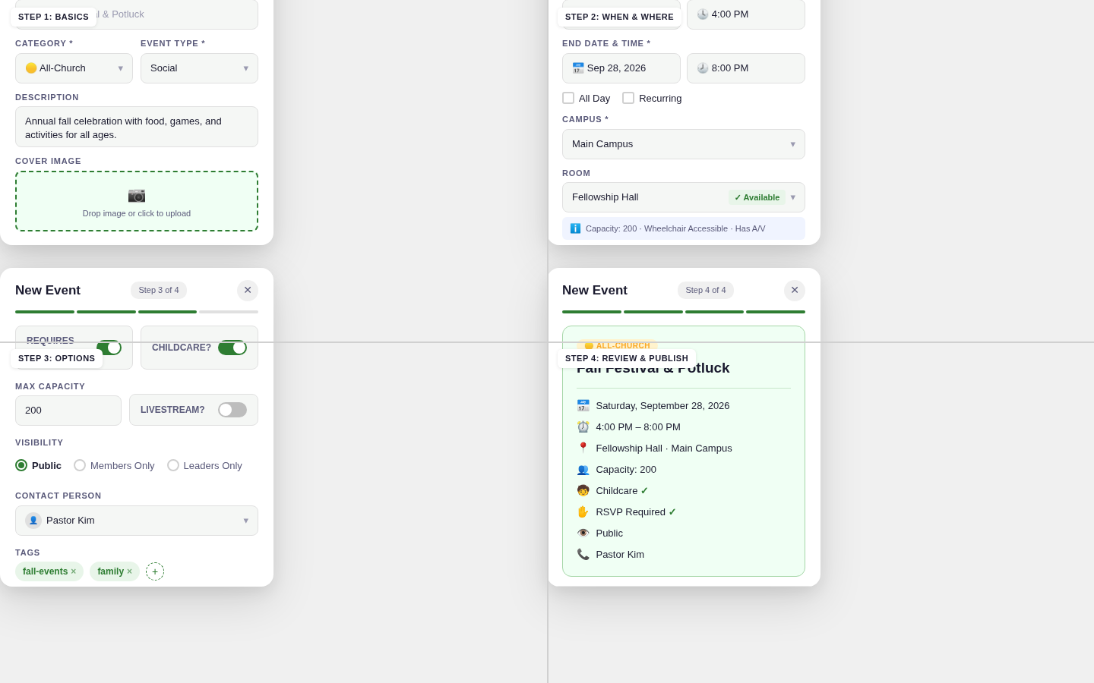

You now have all 4 web mockups complete:

| # | Screen | ✓ |
|---|--------|---|
| 1 | Dashboard/Home | ✓ |
| 2 | Calendar View (Monthly) | ✓ |
| 3 | Event Detail Flyout | ✓ |
| 4 | Volunteer Schedule | ✓ |
| 5 | Create/Edit Event Modal | ✓ |

Mobile Mockups
Core Screens (Home, Calendar, Event Detail)
Here are your three core mobile screen mockups rendered side by side in iPhone 15 Pro frames:

| Screen | Key Elements |
|--------|-------------|
| **HOME** | Liturgical banner (Ordinary Time · Week 21), scripture card, 4 color-coded upcoming event cards with amenity icons, My Serving chips with confirmed/pending status, prayer focus card |
| **CALENDAR** | August 2026 month grid with today (21) highlighted green, color-coded dot indicators per day, filter chips (Month/Week/Day/List), scrollable event list below the grid |
| **EVENT DETAIL** | Category badge, full metadata (date, time, location, recurrence), description, 2×2 amenities grid, this week's readings, capacity progress bar (47/50), sticky dual-action buttons |
Design consistency:
- Ordinary Time green theme (#2E7D32) across all screens
- 5-tab bottom bar with center FAB (Home & Calendar)
- No tab bar on Event Detail (pushed navigation screen)
- Clean white cards with colored left borders for category
- SF Pro typography with clear hierarchy
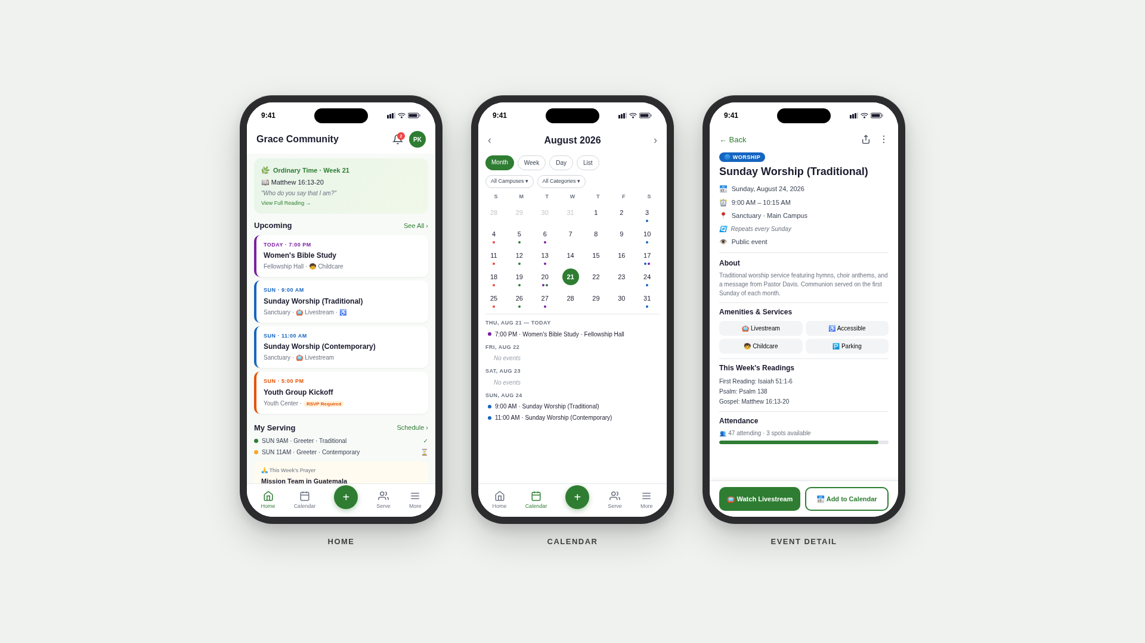

Server Screens (3 screens)
Here are your three Serve/Volunteer mobile mockups rendered side by side in iPhone 15 Pro frames:
| Screen | Key Elements |
|--------|-------------|
| **MY SCHEDULE** | Segment control (active), this week's assignments with confirmed (green) and pending (yellow) states, confirm/decline/swap buttons, next week preview, serving stats with streak counter |
| **OPENINGS** | Amber alert banner ("3 roles need volunteers"), three gap cards (Nursery, Usher, Sound Tech) with orange dashed borders and "Sign Me Up →" green buttons, skills-matching footer |
| **SWAP REQUEST** | Incoming swap card from Sarah Park with two-column shift comparison + personal note + accept/decline buttons, outgoing pending request to Mike Rivera with cancel option, completed swaps summary |
Design highlights:
- Segment control — Pill-style toggle (My Schedule / Openings / Swaps) with green fill on active segment and red notification dot on Swaps
- Status system — Green confirmed cards, yellow pending cards, orange gap cards with dashed borders
- Swap comparison — Side-by-side "THEIR SHIFT" vs "YOUR SHIFT" layout makes the trade-off immediately clear
- Gamification — Stats section with serve count and streak 🔥 encourages consistent volunteering
- Urgency — Orange alert banner and dashed-border gap cards create visual urgency without being aggressive

Full Mockup Summary
You now have all visual mockups generated:
| # | Screen | Type | ✓ |
|---|--------|------|---|
| 1 | Dashboard/Home | Web | ✓ |
| 2 | Calendar View (Monthly) | Web | ✓ |
| 3 | Event Detail Flyout | Web | ✓ |
| 4 | Volunteer Schedule | Web | ✓ |
| 5 | Create/Edit Event Modal | Web | ✓ |
| 6 | Home / Calendar / Event Detail | Mobile (3-up) | ✓ |
| 7 | My Schedule / Openings / Swap | Mobile (3-up) | ✓ |

Create Event flow and Notifications & Groups screens
Here are your final mobile mockups — the Create Event flow and Notifications & Groups screens:
| Screen | Key Elements |
|--------|-------------|
| **CREATE EVENT (Steps 1–2)** | Step 1 — Basics: title, category, type, description, image upload. Step 2 — When & Where: date/time pickers, campus/room dropdowns, green "✓ Available" badge, capacity info |
| **CREATE EVENT (Steps 3–4)** | Step 3 — Options: RSVP/Childcare/Livestream toggles, visibility radios, contact, tags. Step 4 — Review: full summary card on light green background with Save Draft + Publish buttons |
| **NOTIFICATIONS & GROUPS** | Notifications: unread/read states with colored left borders, filter tabs, action buttons (Sign Up →). Groups: 3 color-coded group cards (Women's Study, Worship Team, Missions) with member count and leader info |
Design highlights:
- Progressive disclosure — Progress bars fill 25% → 50% → 75% → 100% across the wizard steps
- Conflict-free design — Room availability confirmed inline with green badge
- Notification urgency — Unread items have bold text + colored borders (green for reminders, orange for volunteer alerts)
- Group personality — Each group has a unique accent color and emoji icon for quick scanning

Complete Mockup Set — All Done! ✅
| # | Screen | Type | ✓ |
|---|--------|------|---|
| 1 | Dashboard/Home | Web | ✓ |
| 2 | Calendar View (Monthly) | Web | ✓ |
| 3 | Event Detail Flyout | Web | ✓ |
| 4 | Volunteer Schedule | Web | ✓ |
| 5 | Create/Edit Event Modal | Web | ✓ |
| 6 | Home / Calendar / Event Detail | Mobile (3-up) | ✓ |
| 7 | My Schedule / Openings / Swap | Mobile (3-up) | ✓ |
| 8 | Create Event (Steps 1-4) + Notifications & Groups | Mobile (3-up) | ✓ |

